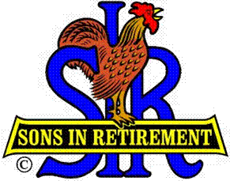
Las Trampas Branch 116
BEC Meeting Agenda
August 19, 2019, 9:30 AM
The Mission of SIR is to improve the lives of our members through fun activities and events – while making friends for life.
Hawaiian Shirt Day
09:15 Coffee Available
09:30 Call to order; Secretary confirm a quorum
09:31 Secretary – Fred Schafer – Approval of July 15 minutes
09:33 Treasurer – Jim Nickels – Report, Missed Luncheon Receipts
09:38 Standing Reports
- Attendance – Jim Flessner – Attendance, Guests and Visitors
- Membership – Phil Goff – New Members to be inducted,
Darrel Dummet (Fred Schafer), Jamie Watson (Art Donaldson),
and Leo Vardas (Dick Savage)
- Nominating Committee – Marty Katz; Slate for 2020 for approval
- Department Head Reports:
Recruitment – Don Schroeder – Guests:
Paul Russell - Gary Boswell and Dr Bob Wells (Don Benioff)
Activities – Fred Wachowicz – New Member Follow Up
Publicity- for Jim McCormick – Publicity Signs; Facebook
09:59 Big SIR Report – Jerry Hicks
- Reschedule Regional Branch Officer Training to Friday, Nov 1, at the Rossmoor Event Center
- Voting procedure if nominations from the floor; Need help
- State Conference - Aug 6-18 at Thunder Valley Resort
- Review Membership Discussion and tie it in to New Member Follow-up
- Need nearly 26 additional guests in the next three months!
- Little SIR Report: Speaker - Bob Fish, USS Hornet
10:08 Old Business
- TBA
10:12 New Business:
- Non Dues payers no longer members
- Branch Operating Procedures Manual
10:20 Other Discussion
10:20 Adjourn; Next BEC Meeting, September 16, 0930 (Kathy Hicks’ Birthday)

